 | EUROPEAN COMMISSION  DIRECTORATE-GENERAL  INFORMATICS  Information Systems Directorate

European Commission
UC0170 - eTrustEx Admin Console - Access Help

Date: | 08/06/2015
Version: | 0.001
Authors: | Anamaria BATRINU
Revised by: | Olivier DERVEAU
Approved by:
Public:
Reference Number:
TABLE OF CONTENTS
1. Use-Case Description 5
1.1. Primary Actor 5
1.2. Definitions, Acronyms and Abbreviations 6
1.3. References 6
1.4. Context Diagram 6
2. Flow of events 6
2.1. Consult and Download CIPAdmin User Guide 6
2.1.1. User chooses to see CIPAdmin User Guide 6
2.1.2. System opens a page containing the User Guide 6
2.1.3. User consults CIPAdmin User Guide 6
2.1.4. User downloads CIPAdmin User Guide 6
2.1.5. Flow ends. 6
2.2. Consult and Download CIPAdmin Frequently Asked Questions (FAQ) 6
2.2.1. User chooses to see CIPAdmin FAQ 6
2.2.2. System opens a page containing the FAQ 6
2.2.3. User consults CIPAdmin FAQ 7
2.2.4. User downloads CIPAdmin FAQ 7
2.2.5. Flow ends. 7
2.3. Consult Contact information 7
2.3.1. User wants to consult contact information 7
2.3.2. System opens a page containing the contact information 7
2.3.3. User sees the contact information provided 7
2.3.4. Flow ends. 7
2.4. Alternative Flows 7
2.4.1. A1: at steps 2.1.3, and 2.2.3 User chooses to go back 7
2.5. Exceptional Flows 7
2.5.1. E1: at steps 2.1.2 or 2.2.2, an error occurs when pdf file is loaded 7
2.5.2. E2: at step 2.1.4 or 2.2.4, an error occurs when downloading the pdf file 7
3. Special Requirements 8
3.1. Interface(s) with other Systems 8
3.2. Security Requirements 8
3.3. Other Special Requirement 8
4. Preconditions 8
5. Post conditions 8
6. Additional Information 8
6.1. Includes 8
6.2. Extends 8
7. Mock-up screens 8

Document History

Version | Date | Comment | Modified Pages
0.001 | 08/06/2015 | BATRIAN: Created (CIPADMIN-179) | All

Use-Case Description
This use case depicts the help that CIPAdmin offer to its users.
The "Help" feature is exposed on the CIPAdmin module of e-TrustEx platform.
In the remainder of the document the CIPAdmin application will be referred to as the System.

Primary Actor
A human user can access the Help feature via CIPAdmin interface. All user roles have access to this feature.
In the remainder of the document, the user will be referred to as User or by his/her role, in those cases where role specific rules apply.

Definitions, Acronyms and Abbreviations
Acronym, Abbreviation or Definition | Explanation
CIPA | Common Infrastructure for Public Administrations
CIPADMIN | CIPA AdminConsole
UC(s) | Use Case(s)

References
Ref. | Reference | Title / description | Version | Date
[R1]

Context Diagram
N/A

Flow of events

Consult and Download CIPAdmin User Guide

User chooses to see CIPAdmin User Guide
To consult CIPAdmin User Guide, user must follow the menu path Help => User Guide (please see Figure 1 - Help Menu).

System opens a page containing the User Guide
System opens a page and loads the pdf CIPAdmin User Guide. The CIPAdmin User Guide is only provided in English (please see Figure 2 - CIPAdmin User Guide Popup Page).

User consults CIPAdmin User Guide

User downloads CIPAdmin User Guide
User can use the download option at the top of the page to download the user guide.

Flow ends.

Consult and Download CIPAdmin Frequently Asked Questions (FAQ)

User chooses to see CIPAdmin FAQ
To consult CIPAdmin FAQ, user must follow the menu path Help => FAQ.

System opens a page containing the FAQ
System opens a popup page and loads the FAQ pdf. The CIPAdmin FAQ is only provided in English (please see Figure 2 - CIPAdmin User Guide Popup Page).

User consults CIPAdmin FAQ

User downloads CIPAdmin FAQ
User can use the download option at the top of the page to download the FAQ.

Flow ends.

Consult Contact information

User wants to consult contact information
To consult contact information, user must follow the menu path Help => Contact.

System opens a page containing the contact information
System opens the contact page containing the email address of CIPAdmin Support team as the contact information. No phone number or physical address will be provided. The email address is the only mean provided for contacting CIPAdmin team and it is configured in the metadata.
Please see Figure 3 - Contact Popup Page.

User sees the contact information provided
User can use the contact email address to contact CIPA team via an external system (ex. Microsoft Outlook, IBM Lotus Notes etc.).

Flow ends.

Alternative Flows

A1: at steps 2.1.3, and 2.2.3 User chooses to go back
- User closes the popup
- System displays the original page
- Flow ends

Exceptional Flows

E1: at steps 2.1.2 or 2.2.2, an error occurs when pdf file is loaded
- System logs the error
- System informs the user about the error
- Flow ends

E2: at step 2.1.4 or 2.2.4, an error occurs when downloading the pdf file
- System logs the error
- System informs the user about the error
- Flow ends

Special Requirements

Interface(s) with other Systems

Security Requirements

Other Special Requirement

Preconditions
- User must be registered user of CIPAdmin tool
- User must be logged in & successfully authenticated on the e-TrustEx Admin Console

Post conditions
- [Success] The User can successfully consult/download CIPAdmin User Guide / FAQ, and see the contact information.
- [Failure] The System logs the failure reason and the context, the use case is aborted and the primary actor has been notified of the reasons.

Additional Information

Includes
- For operation authorization: UC 0100 - eTrustEx Admin Console - Authenticate and Authorise User
- For logging: UC 0110 - eTrustEx Admin Console - Log CIPAdmin User Actions

Extends

Mock-up screens
Figure 1 - Help Menu
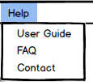
Figure 2 - CIPAdmin User Guide Popup Page
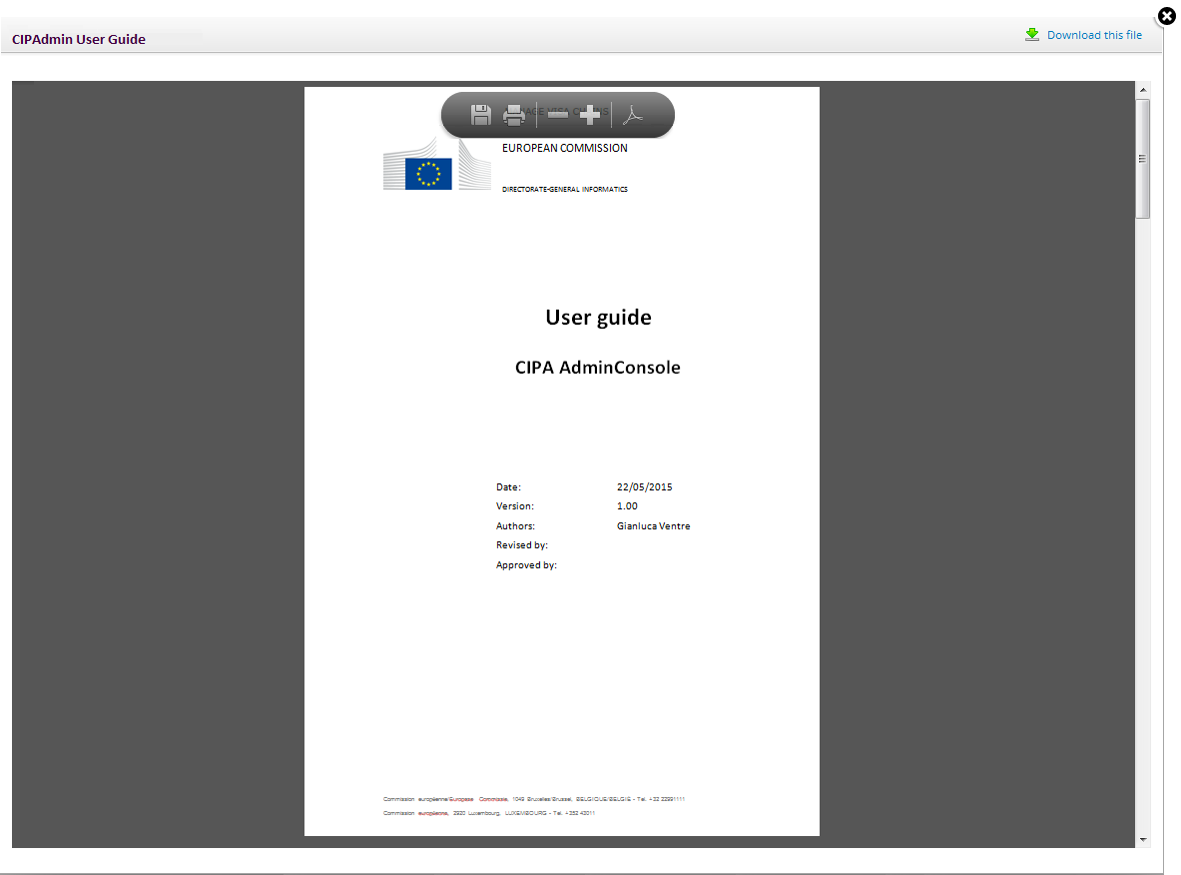

Figure 3 - Contact Popup Page
